CONNECTICUT
Online & Social Media Content Library

The following is suggested content for your organization’s Facebook page, Instagram page, Twitter feed, website or newsletters. You have permission to use content in its entirety or extract excerpts. You may personalize as necessary.

If you would like to request other images to use in conjunction with this content, please contact our Marketing & Communications Department at info@byebyemattress.com

Available Logos
Our logo is available in a horizontal and a vertical layout. Below are PNG files that you may copy and resize. Contact us if a higher resolution or a different file type is needed.

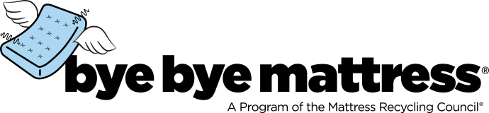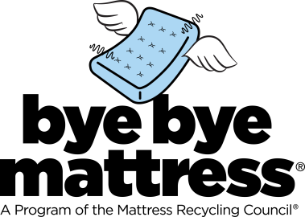

Available Photos & Graphics
A Dropbox of commonly requested photos, illustrations and infographics is available. Contact our Marketing & Communications Department at info@byebyemattress.com for further assistance.

Facebook/Instagram
We are proud to be a Mattress Recycling Council @ByeByeMattress collection site! We accept used mattresses and box springs for free and recycle them. Find out more: [website/link for your facility]

Thanks to Mattress Recycling Council’s @ByeByeMattress program, we are diverting mattresses and box springs from landfills and deterring illegal dumping. [town/city/county/state] residents can drop off these items at our facility for free! [website/link for your facility]

Your used mattress and box spring can have a better life. Let Mattress Recycling Council’s @ByeByeMattress recycle them. Drop them off for free at our facility: [website/link for your facility]

Say @ByeByeMattress and hello recycling! Drop off your used mattress or box spring for free at our facility and let it become something new such as carpet padding, insulation or mulch: [website/link for your facility or use our Journey of a Mattress video – http://bit.ly/JourMatt or infographic - https://byebyemattress.com/why-recycle/]

What happens to your mattress after you drop it off with us? It gets cut open and separated into steel, foam, fiber and wood. Those materials get #recycled into many other useful products. @ByeByeMattress http://bit.ly/JourMatt

X (formerly Twitter)
We are proud to be a @ByeByeMattress collection site. Mattresses and box springs accepted free and recycled into many other useful products.

Mattresses and box springs can be dropped off at no cost at our facility and are recycled thru @ByeByeMattress: [short link for your website]

Stop by [location] today! We’re collecting used mattresses and box springs for free. They’ll be recycled through @ByeByeMattress.

#DYK: The mattresses you drop off are cut open and separated into steel, foam, fiber and wood. These materials are #recycled thanks to @ByeByeMattress. https://byebyemattress.com/why-recycle/

#ICYMI: We’re recycling the mattresses you drop off. They get #recycled into many other useful products thanks to @ByeByeMattress. http://bit.ly/JourMatt

Newsletter/Website Content of Varying Lengths
~20 Words: We are participating in the Mattress Recycling Council’s Bye Bye Mattress program – free drop off of mattresses and box springs.

~50 Words: The Mattress Recycling Council’s Bye Bye Mattress program recycles more than 190,000 mattresses a year in Connecticut. As a participating collection site, we accept mattresses and box springs for free at [facility name], located at [facility address]. To learn more about how the program works in Connecticut, visit ByeByeMattress.com.

~100 Words: The Mattress Recycling Council’s Bye Bye Mattress program recycles more than 190,000 mattresses a year in Connecticut. As a participating collection site, we accept mattresses and box springs for free at [facility name], located at [facility address] during the following hours of operation: [hours open to public]. Recycling mattresses diverts valuable material from the waste stream and turns them into other useful products instead. To learn more about how the program works in Connecticut visit ByeByeMattress.com.
~150 Words: The Mattress Recycling Council’s Bye Bye Mattress program recycles more than 190,000 mattresses a year in Connecticut. As a participating collection site, we accept mattresses and box springs for free at [facility name], located at [facility address] during the following hours of operation: [hours open to public]. [Insert any other additional details about your site or participation].

Thanks to this program, these units are diverted from the waste stream and used to make other useful products such as carpet padding, insulation, filters and mulch. To learn more about how the program works in Connecticut, visit ByeByeMattress.com.

Website Directory Link
If you mention our website by name, use ByeByeMattress.com.

Example
“Did you know you can now drop off your mattresses and box springs at no charge? Visit ByeByeMattress.com and use the recycling locator to find the nearest free drop-off location.”

If you simply list our program name and a link, refer to our program as any of the following:
Mattress Recycling Council’s Bye Bye Mattress program
Bye Bye Mattress, a program of the Mattress Recycling Council
MRC’s Connecticut Bye Bye Mattress recycling program

Link any of the above to the Bye Bye Mattress homepage (http://www.byebyemattress.com) or the Connecticut program page (https://byebyemattress.com/programs-by-state/connecticut/).

Tag and Follow us on Social Media
Bye Bye Mattress is on Facebook, Instagram and X. Use @ByeByeMattress or #ByeByeMattress to engage with us.

